Battery Level Indicator

Description:
The Battery Level Indicator project is a simple electronic circuit used to display the approximate charge level of a battery using LEDs.
In this project, four LEDs glow progressively to indicate different voltage levels of a 9V battery.
It is a basic and effective way to understand voltage indication, LED operation, and resistor usage in electronic circuits.
Block Diagram:
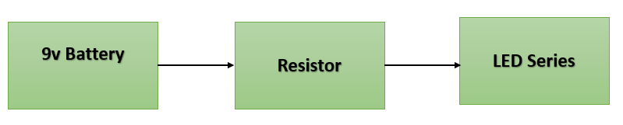

Pinout / Circuit Connection:
- 9V Battery (+) → 1kΩ Resistors → LED Anodes
- LED Cathodes → 9V Battery (–)
- Each LED is connected in parallel with its own 1kΩ resistor

Components Required:
- 4 × LEDs
- 4 × 1kΩ Resistors
- 1 × 9V Battery
- Battery Connector
- Breadboard
- Jumper Wires

Working Principle:
The battery level indicator works on the principle of voltage division and LED forward voltage characteristics.
Each LED requires a minimum voltage to turn ON.
As the battery voltage increases, more LEDs receive sufficient voltage and glow.
Thus, the number of glowing LEDs indicates the approximate battery charge level.

Operation (Step-by-Step):
• Connect the 9V battery to the breadboard
• Connect each LED in series with a 1kΩ resistor
• Connect all LED-resistor pairs in parallel across the battery
• Power ON the circuit
• Observe the LEDs glowing based on the battery voltage
• More LEDs ON indicate higher battery level
• Fewer LEDs ON indicate lower battery level
Indication Table (Approximate):
- 1 LED ON → Low Battery
- 2 LEDs ON → Medium Battery
- 3 LEDs ON → Good Battery
- 4 LEDs ON → Fully Charged Battery

Conclusion: (Predefined/self-written)
The Battery Level Indicator project provides a simple and visual method to monitor battery voltage using LEDs.
It helps students understand basic concepts such as voltage levels, current limiting using resistors, and LED behavior.
This project can be further enhanced by using comparators, ICs, or microcontrollers for more accurate battery monitoring.
For Your References:
[1] A. P. Godse and U. A. Bakshi, Electronic Devices and Circuits, 2nd ed. Pune, India: Technical Publications, 2016.

